**SOP for repetitive Issue:**

1. For Black screen, NLA issue and Unable to login to any sever, below are the steps process to trouble shoot.

* First steps we need to try login through local credential as well as cyber arch in case of prod server, If unable to login thru these credentials, check **activity logs** and **resource health**. There should not be any failure in azure resource health.
* Then check Metrics for portal with “average” aggregation and see the fluctuations like at which point of time available memory went down , check CPU usage too , based on the fluctuations we can check the process at that moment.
* 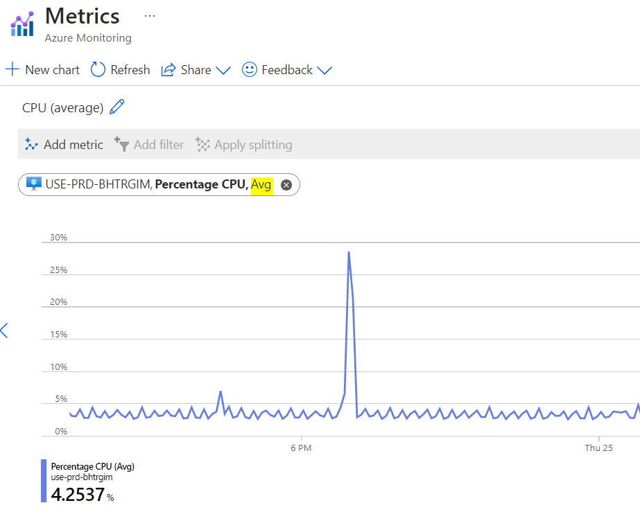

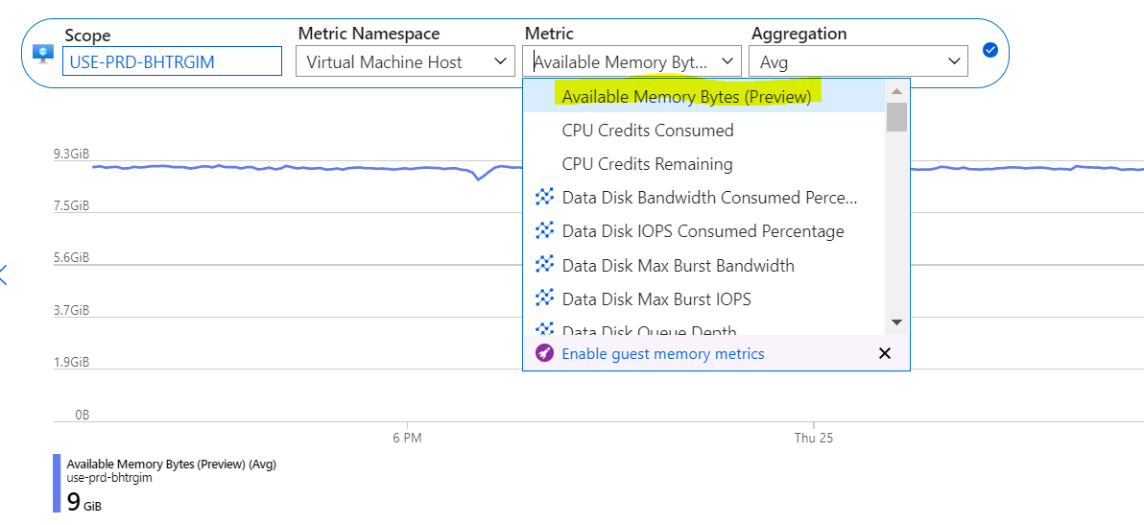

Next, try to run commands from powershell inside run command options. If no command executed , it means server is not responding from OS end.  
  
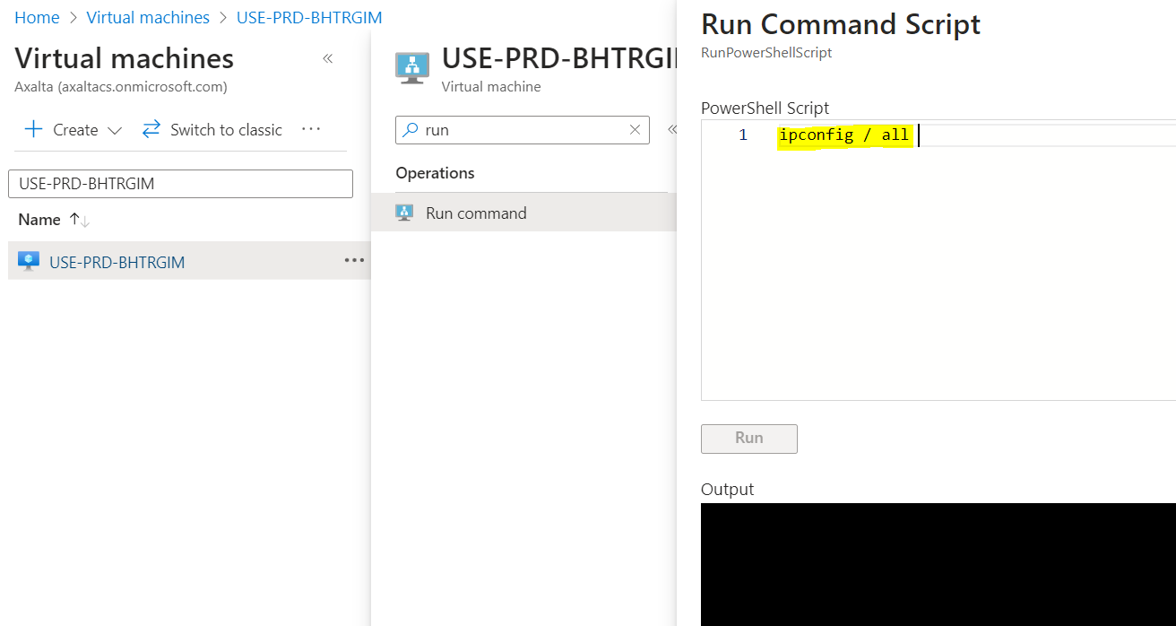

an additional step before crashing the server:

* Try to access the Azure Serial Console on the server:
  + If it works, it should show an interface like this one:

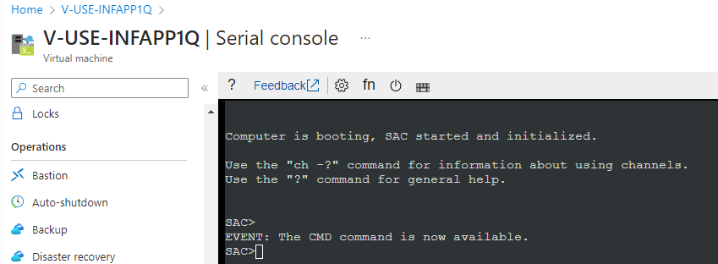

* + Try to create a CMD channel by issuing the “cmd” command:

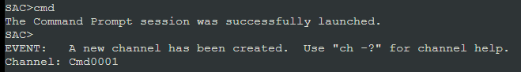

* + The list of open channels can be seen by issuing the “ch” command

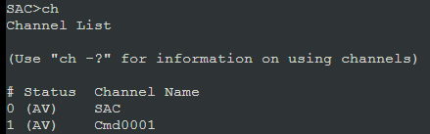

* + Try to access the CMD channel by issuing the “ch -si 1” command:



* + Press “enter” on the prompt:

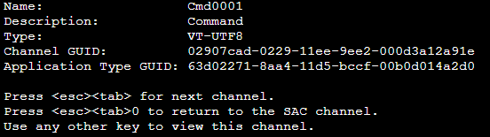

* + Try to authenticate using local credentials (do not enter anything on the “Domain” filed, just press enter):

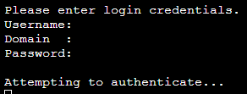

* + If access is gained, perform troubleshooting tasks like:
    - Tasklist (to identify running processes)
    - Taskkill /PID (Kill process with PID # if too much CPU is being used)
    - Other troubleshooting steps that the Wintel team could identify.
  + If no response is provided by the server in 5 minutes (either successful login or bad credentials) this method can be considered as non-working.

* Then crash the VM via generate NMI for troubleshoot logs, before send NMI, it should be cleared that wintel team must configured path for logs. If not generated check EMS is Enable or not, you can Enable EMS with approval.
* But before crashing the VM , team should get the application owner approval as after crash, server will be rebooted automatically.
* Check performance diagnostics report if it installed on that server, if not we can install only after getting approval from omar as it will incurred some additional cost.
* Once server is rebooted successfully, ask wintel team to share findings at OS end for the issue.
* You can also check the task manager inside the server and see the performance , memory and CPU usage.

**Note**: No User data should save any data in C-drive memory, otherwise it will also leads to slowdown the server.

|  |  |  |
| --- | --- | --- |
| **Assignment group** | **Short description** | **Tasks** |
| Configuration Management Team | Please add the server in CMDB | SCTASK0075670 |
| CSIRT | Please add servers in QRADAR | SCTASK0075669 |
| SCCM/ Intune Platform Support | Please validate VM server from SCCM end | SCTASK0075668 |
| SCOM Admin Support | Please add servers in monitoring | SCTASK0075666 |
| WINTEL & Active Directory Admin | Please perform DNS entries and OS hardening | SCTASK0075663 |